1. Cmd: **docker images**

List all the images present in local



1. Cmd: **docker pull <image_link>**

Download image from docker hub to local machine.

Eg: docker pull docker/getting-started

The above command downloads “getting-started” image into local.

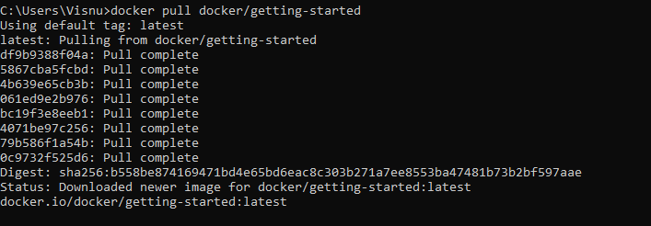

1. Cmd: **docker run -p 5000:5000 visnudev/hello-visnu-app**

To run a docker image in detached mode.

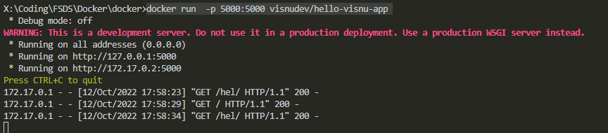

1. Cmd: **docker ps**

Displays the details of currently running docker images.



1. Cmd: **docker stop <container_ID>**

It stops the running image belong to the container ID.



1. Cmd: **docker rmi -f visnudev/hello-visnu-app**

Removes the docker image forcefully.

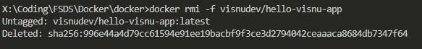

1. Cmd: **docker build -t visnudev/hello-visnu-app .**

Build an image with the specified name

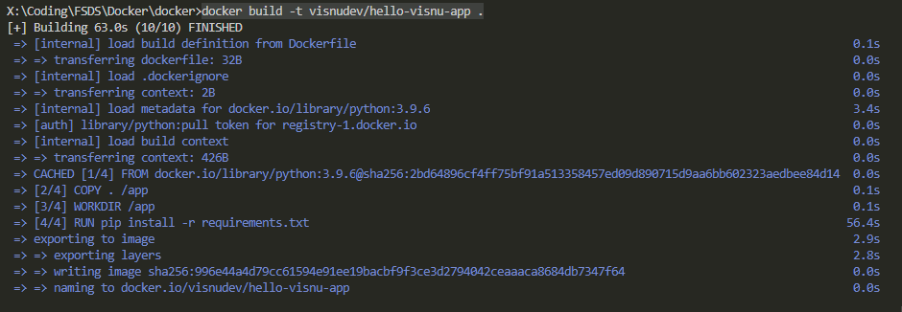

1. Cmd: **docker push visnudev/hello-visnu-app:latest**

Push(upload) the mentioned image into Dockerhub.

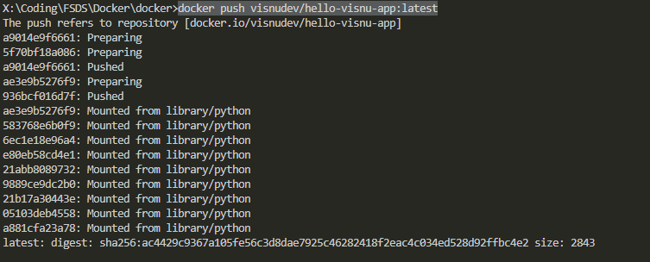

1. Cmd: **docker login -u "visnudev" -p mypasswd**

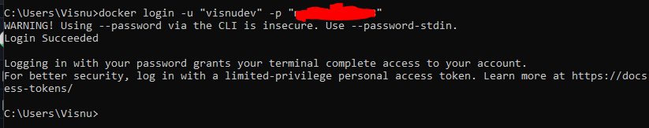

1. Cmd: **docker info**

Displays the system wide information

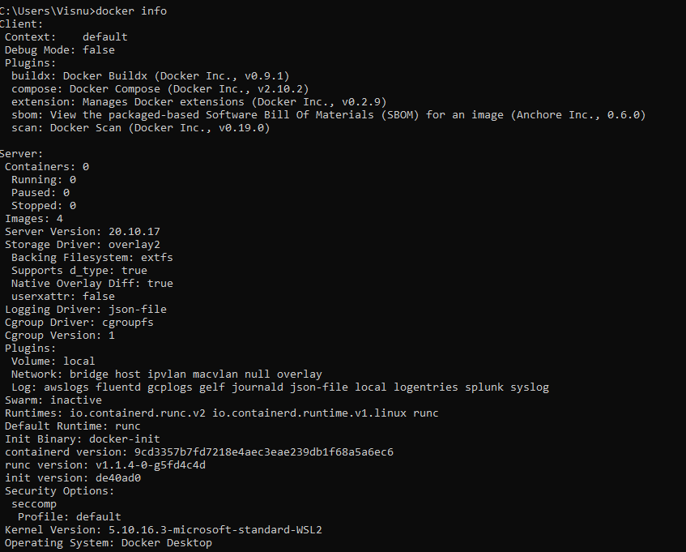

1. Cmd: docker run **--name my_container** -p 5000:5000 visnudev/hello-visnu-app

Run the image with specified container name.

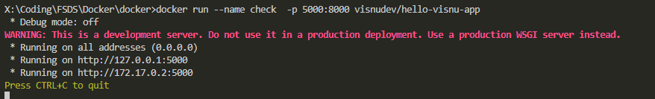

1. Cmd: **docker container ls**

List all the available containers



1. Cmd: **docker container port <container_name>**

Shows the port at which the container is running.



1. Cmd: **docker** **container rename <current_name> < new_name>**

Renames the container. From “check” to “visnu_container”



1. Cmd: **docker logout [server]**

Logout from a docker registry.

